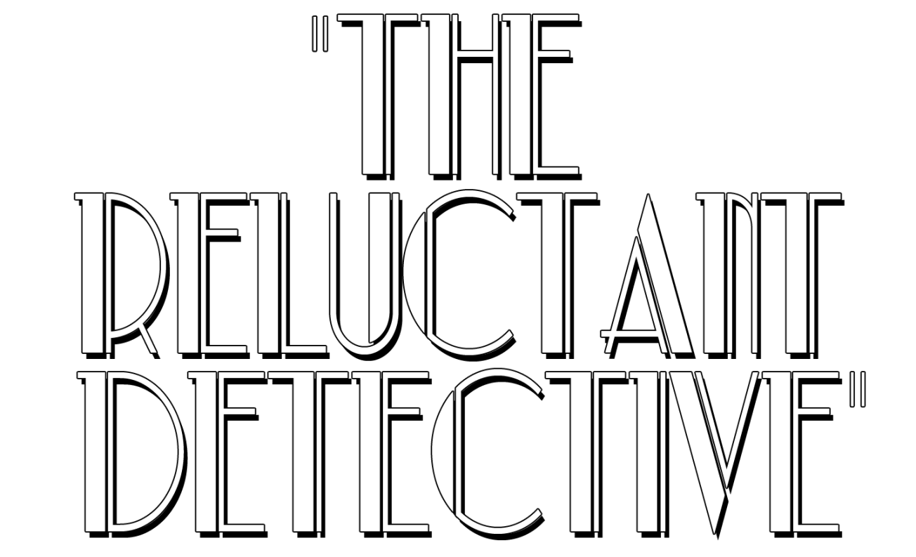
PRESS RELEASE
For Immediate Release

Press Contact:
Steve Thompson
Thompson Communications
856-942-4434
steve@thomcomm.net

THE RELUCTANT DETECTIVE
PRODUCED ENTIRELY IN CONNECTICUT
COMMUNITY SCREENING SUNDAY JUNE 22, 4pm
AT THE HISTORIC BIJOU THEATRE
BRIDGEPORT, CONNECTICUT

STRATFORD, Conn., June 2014— The Reluctant Detective, written, produced, and directed by Stratford, CT resident Christopher S. Lombardi will be shown in a community screening on Sunday, June 22, 2014 at 4PM at the historic Bijou Theatre in Bridgeport, CT. The screening is offered as a community screening available to the creative community in the area in which it was produced. Tickets are available are available at The Reluctant Detective website, on a first come, first served basis. A donation of a non-perishable food item is requested, which will be donated to a local food bank.

The historic Bijou Theatre in Bridgeport is the perfect location for screening this film, because according to Christopher S. Lombardi: “The film has a definite vintage period feel. As much as I wasn’t trying to make a 1940’s film in the present time, there are certain elements that harken back to those days. Some elements include the pattern of speech, the props, the wardrobe and the credit sequences. I think that the public will notice all the little touches that went into making this film look and feel like a vintage screwball comedy.”

About the Film

The Reluctant Detective revolves around Bennett Stephens, a well-known actor on a highly rated Cable-TV crime show.

Set in the present day, while on vacation with his wife in her hometown -- a town that seems to be frozen in time -- he reluctantly gets involved in solving a double homicide. Along the way Bennett meets many friends, foes and colorful characters. Bennett is assisted not only by his lovable wife Kelly, but by his new friend Fish, a street wise but gentle hearted gangster who is also visiting the town on vacation.

Bennett must now rise to the challenge of trying to crack the case!

About the Filmmakers

Writer, producer, director Christopher S. Lombardi is a graduate of Western Connecticut State University with a degree in Communication and Media. Lombardi says “The production of The Reluctant Detective is the story of a filmmaker with a vision and a story to tell, but there is so much more to it too. I was lucky to have some really great shooting locations. We shot at the same train station that Alfred Hitchcock shot scenes of Strangers on a Train.”

The film stars Bristol Pomery as Bennett Stephens, Elise Rovinksy as Kelly Stephens and Lou D’Amato as Fish.

Bristol Pomery is a New York based actor—Queens to be exact. He has worked mostly in Independent film and theatre as well as some TV. He was most recently seen on the FX show The Americans. The Reluctant Detective is the third film Bristol has filmed in Connecticut—the other two are Marathon and Janie Charismanic. Recently, Bristol starred in Driving Miss Daisy at Playhouse on Park in West Hartford.

Elise Rovinksy is a graduate of the Stella Adler Conservatory of Acting. Elise also studied Drama at the University of Gothenburg in Sweden. Elise is living the life of a working actress in New York City. Elise has starred in many feature films, TV commercials and print ads. Her most recent Come Morning had its world Premiere at the Austin Film Festival.

Lou D’Amato is a Southern Connecticut based actor and has starred in many feature films, TV commercials, Cable Television shows and recently 2 TV Pilots. Lou studied with 2 time Academy Award® Nominee Jill Clayburgh in New York and Aaron Spieser in Los Angeles. The first film in which Lou was featured was also filmed in Connecticut, and starred Gregory Peck.

About The Bijou Theatre

The Bijou Theatre is housed in a building over 100 years old, and is one of the oldest buildings in the country that continues to be used as a movie house. It is a multi–functional venue run by people with integrity and an open minded philosophy. The Bijou Theatre is a symposium for film, theatre, art, comedy and music.
# # # #

THE RELUCTANT DETECTIVE
was produced by CL Productions
Christopher S. Lombardi
bennettstephens@ymail.com

Christopher S. Lombardi
is available for interview.

Please Contact Steve Thompson
Thompson Communications
856-942-4434
steve@thomcomm.net

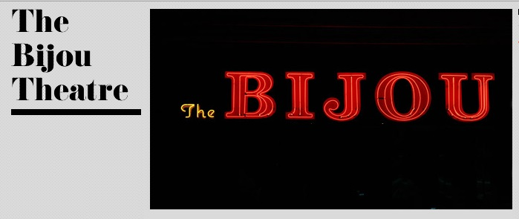

The Bijou Theatre
is located at 275 Fairfied Avenue
in Bridgeport, Connecticut

Box Office 203-332-3228
Bijou Theatre Website

