Thompson Communications
PRESS RELEASE

For Immediate Release
Press Contact:
Steve Thompson
Cell: 856-571-6796
steve@thomcomm.net

Introducing Producer / Director Humberto Rosa
Bringing Award-Winning Work to World-Wide Audiences

(February, 2020 – Los Angeles, CA) At a very young age Humberto Rosa was sure he wanted to become a filmmaker. Born Humberto Gomes da Rosa in Humaitá, Rio de Janeiro. He began by working with his college administration in advertising, where he did his first filmmaking. At age twenty he began film school Universidade estacio de Sá campus Tom Jobim, Rio de Janeiro, where he founded Red Line Films.

In 2014 he directed an ad campaign with his partner Thairon Mendes and Luiz Osório called Transito Amigo that earned a Cannes Lion.

He shot an ad for the champagne Lamborghini (same brand of the car) with the top model Eugenia Kuzmina, who is the wife of Bill Block at Miramax, which they shot at Bill’s home.
Currently working in Los Angeles, he now has six titles in development, and an astounding twenty-six completed film and video titles working with some of the biggest talents in the industry both in Brazil and the US!
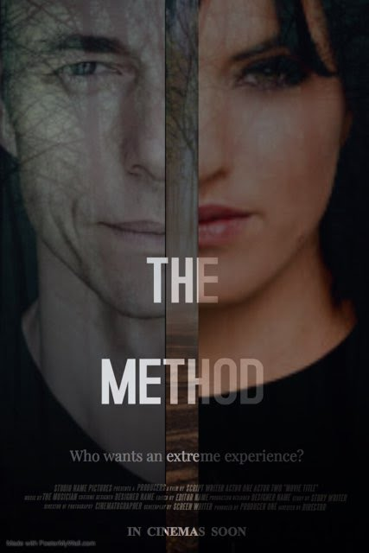

In development is The Method (formerly The Assistant) the story of an ambitious Hollywood assistant who finds herself in a hellish, life-or-death situation when she agrees to live in isolation with an overbearing Method actor who wants an extreme experience far from civilization, while preparing for his next role. Humberto is the director and executive producer, with well known talent attached like Nicky Whelan, Costas Mandylor, and Christopher Showerman.

He is producing Subliminal with Warren Zide producer of American Pie and the Final Destination franchise.

Completed are Don't Look Back written by Jeff Howard (The Haunting of Hill House) and has earned an astounding 17 awards, and 16 nominations.

He is a co-producer of 2119 with Edimilson filho directed by respected Brazilian director Edmilson Filho shot in the USA.
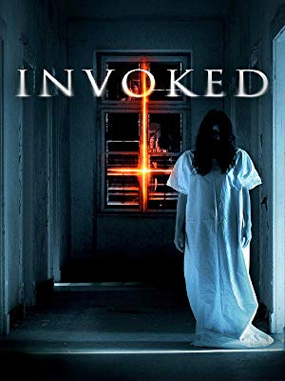
His horror feature Invoked was released in theaters in Thailand, New Zealand, Australia, and Indonésia, was also released in North America, Central America and Europe on Netflix, and is now available on Amazon.

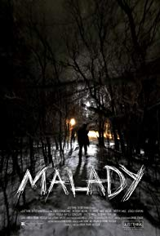
A Consulting Producer on Malady, a horror movie shot in the US about a group of friends who decide to escape the daily hustle and bustle of LA, by going on a camping adventure. But when they encounter an infected man, their adventure soon turns to the fight for survival and now they must escape the Malady.

And producer of Lisa Haisha’s web series, he also interviewed her husband Lee Aaronsohn creator of Two and a Half Men and executive producer (83 episodes) and writer (43 episodes) of The Big Bang Theory.

In 2019 he coproduced a Brazilian horror feature film entitled Meu ódio é minha herança with recognized performers from Brazil like Andre Mattos (Narcos) and Tonico Pereira from Globo tv, which will be released later this year in Brazil.
He is executive producer and producer of a major Brazilian comedy feature film entitled Solteira Quase Surtando that will be released this March 12 at major theaters throughout Brazil.

“I am grateful to have been able to learn so much about such a dynamic industry, and to have been able to work with so many talented people. Film is a collaborative process, and working with great people is a continuing learning experience. Thrilling audiences around the world is the ultimate reward.”

From the time he saw Indiana Jones and the The Last Crusade, he knew he had to become a filmmaker, and now he would love to collaborate someday with Steven Spielberg. That and more is likely on the horizon for this talented filmmaker.

# # # #

Humberto Rosa on IMDb

Humberto Rosa on IMDb Pro

Red Line Filmes site (English)

Humberto Rosa Press Materials

Humberto Rosa is available for interview
By appointment, pending availability

Contact Steve Thompson
steve@thomcomm.com
cell: 856-571-6796

